Module Name: Login Page
Test Case ID: 183
Webpage URL: https://practicetestautomation.com/

● Scenario ID: 3a
Scenario: Review Requirement Document
Test Steps:
1. Open login page.
2. Read all login requirements.
3. Give the requirement data.
4. Read and verify all login requirements .

Screenshots:

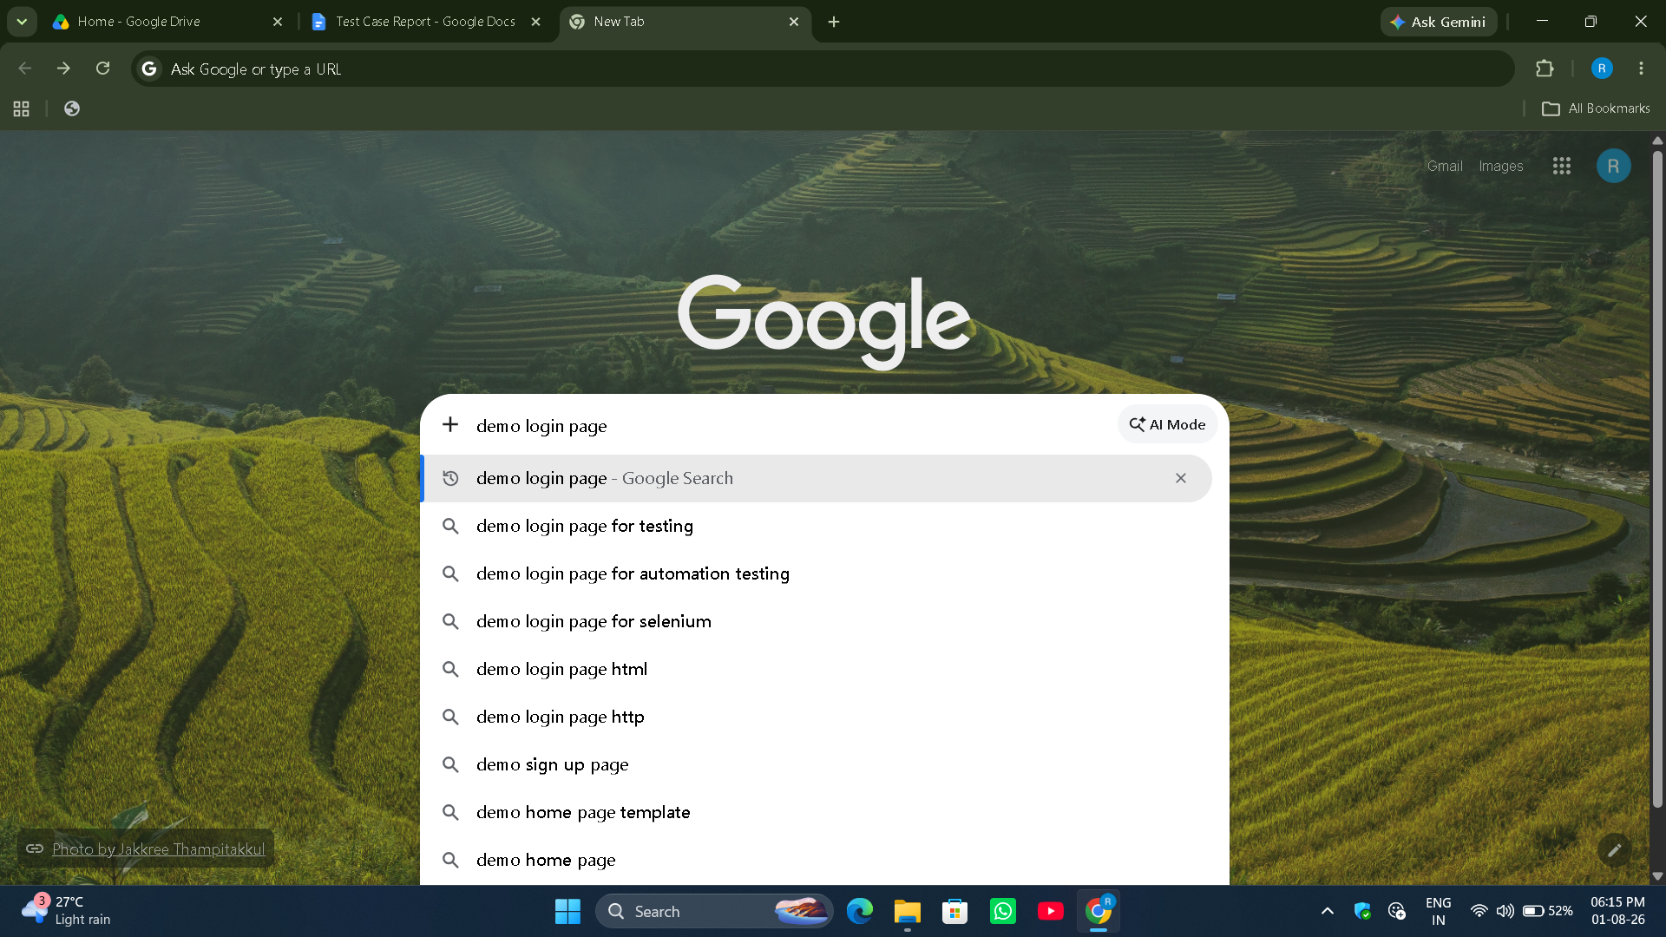
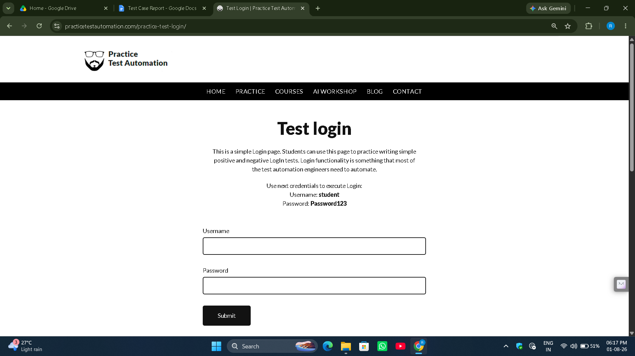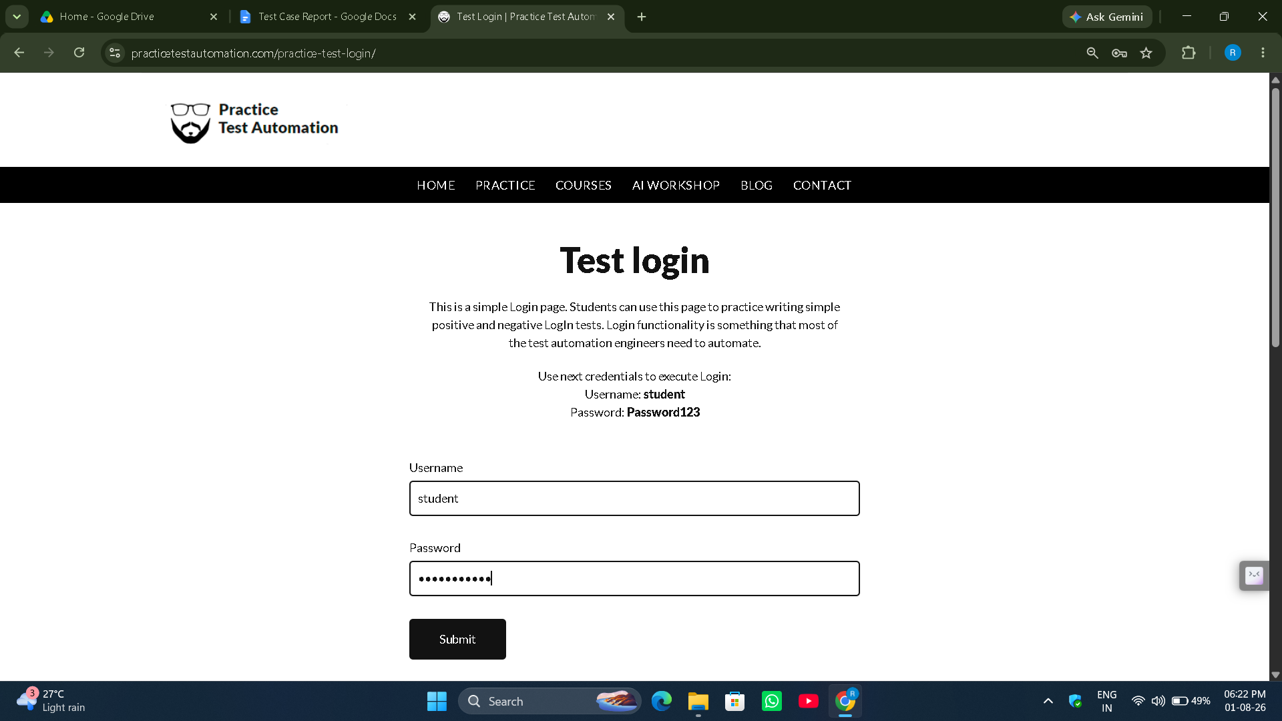
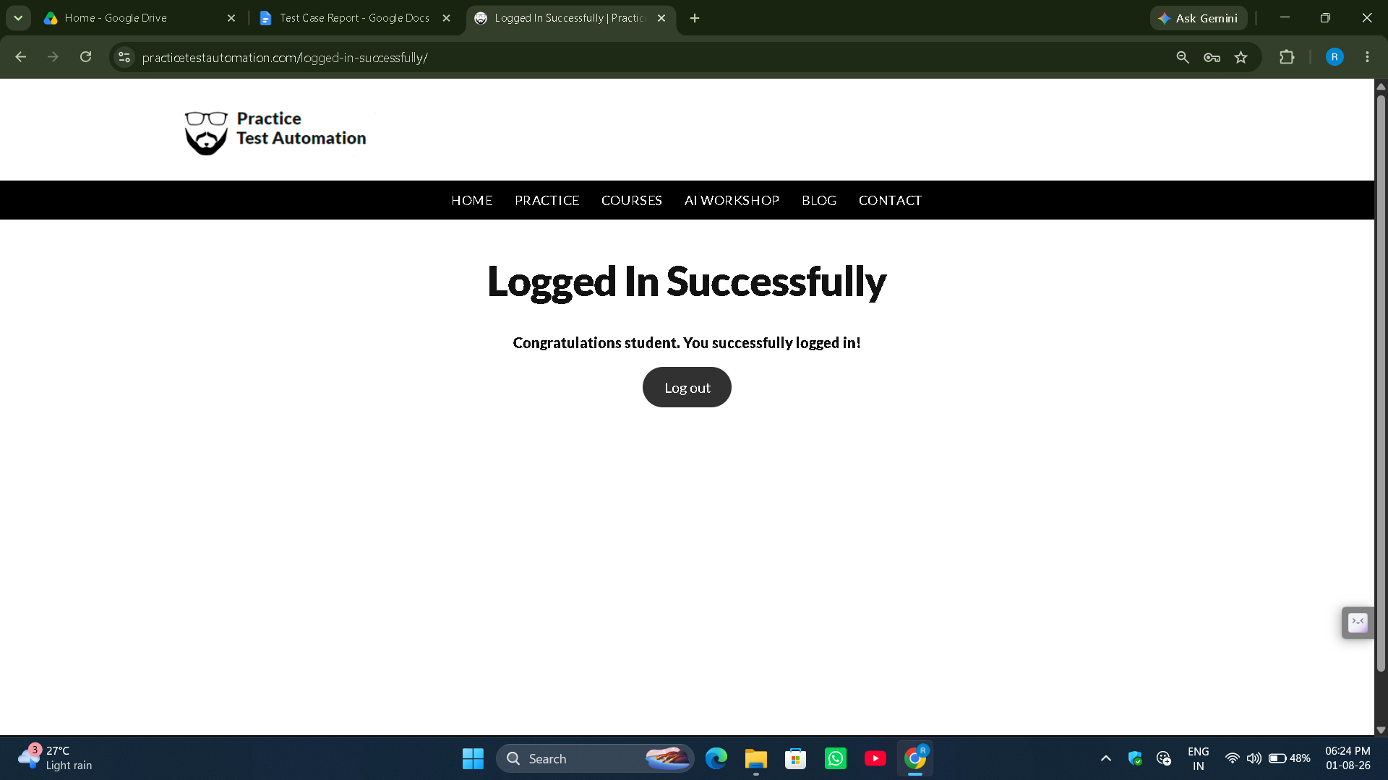

● Scenario ID: 3b
Scenario: Review Source Code
Test Steps:
- Open Login Page.
- Right click on the blank area.
- Click on the view page source.

Screenshots:

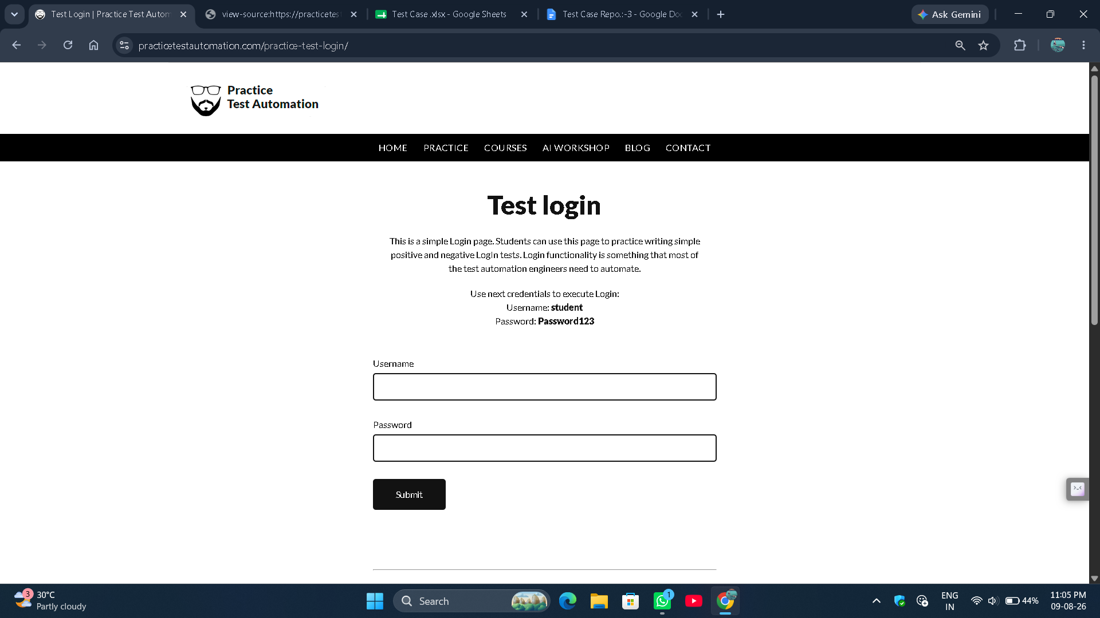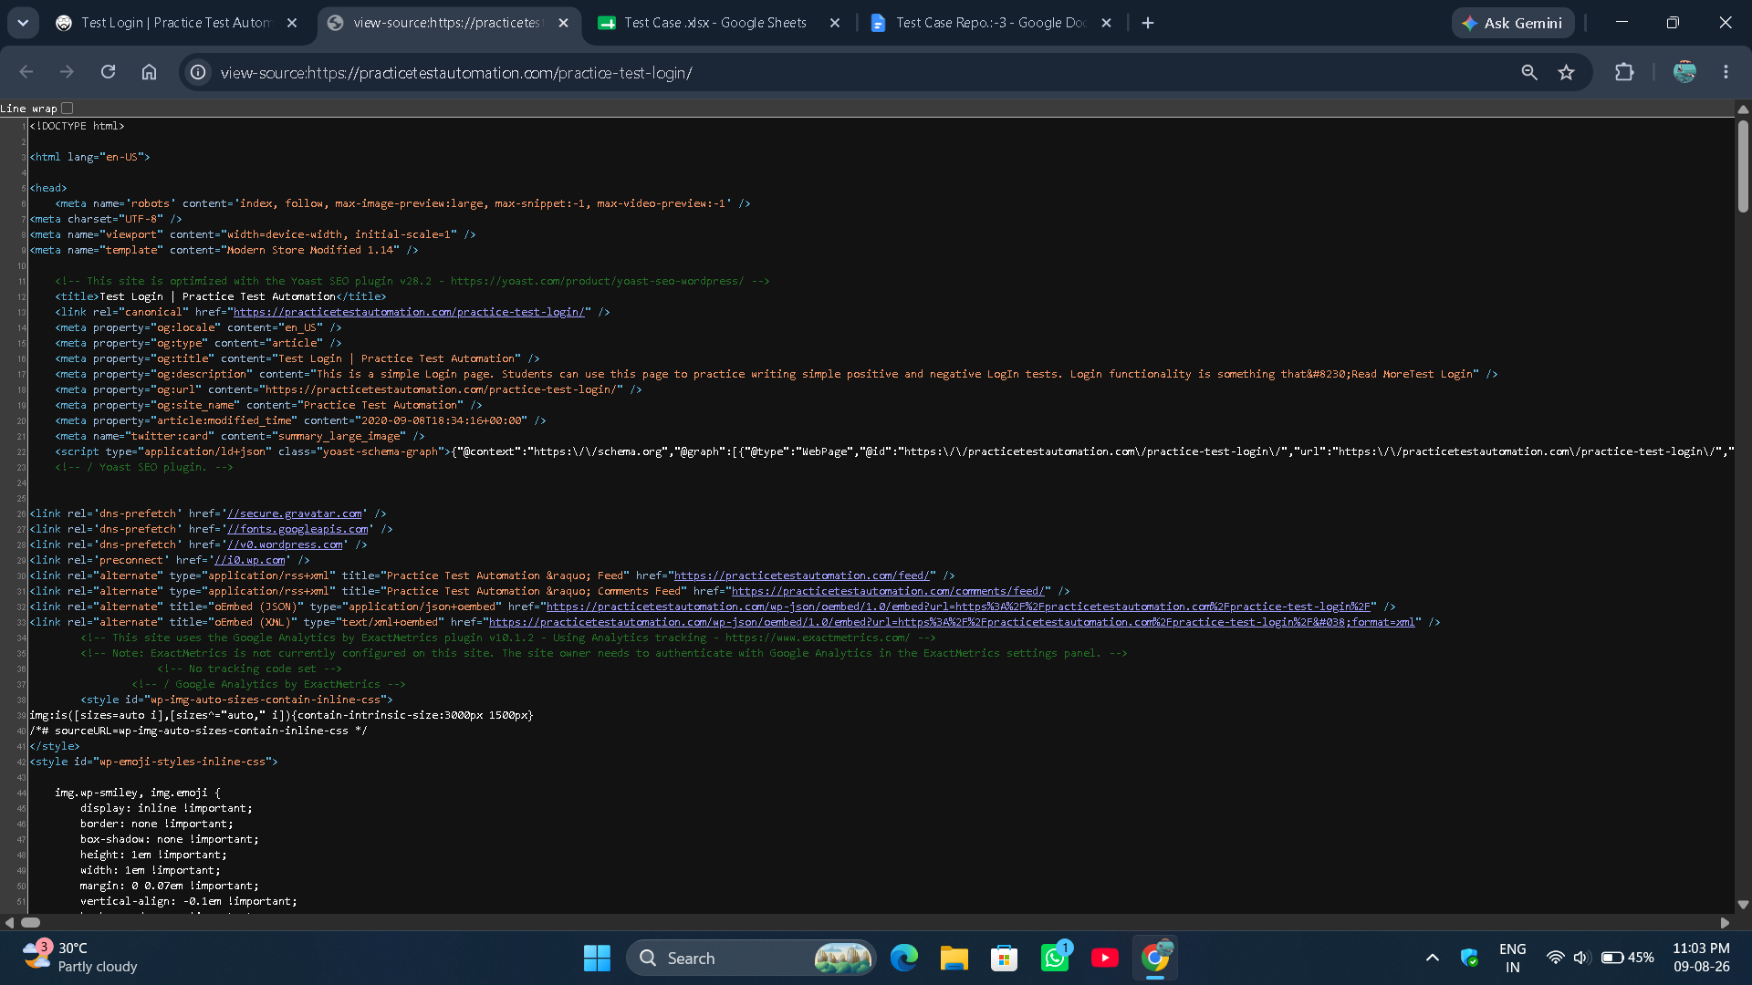

● Scenario ID: 3c
Scenario: Verify Username Field
Test Steps:
- Open Login Page.
- Right click on the blank area.
- Click on the view page source.
Screenshots:

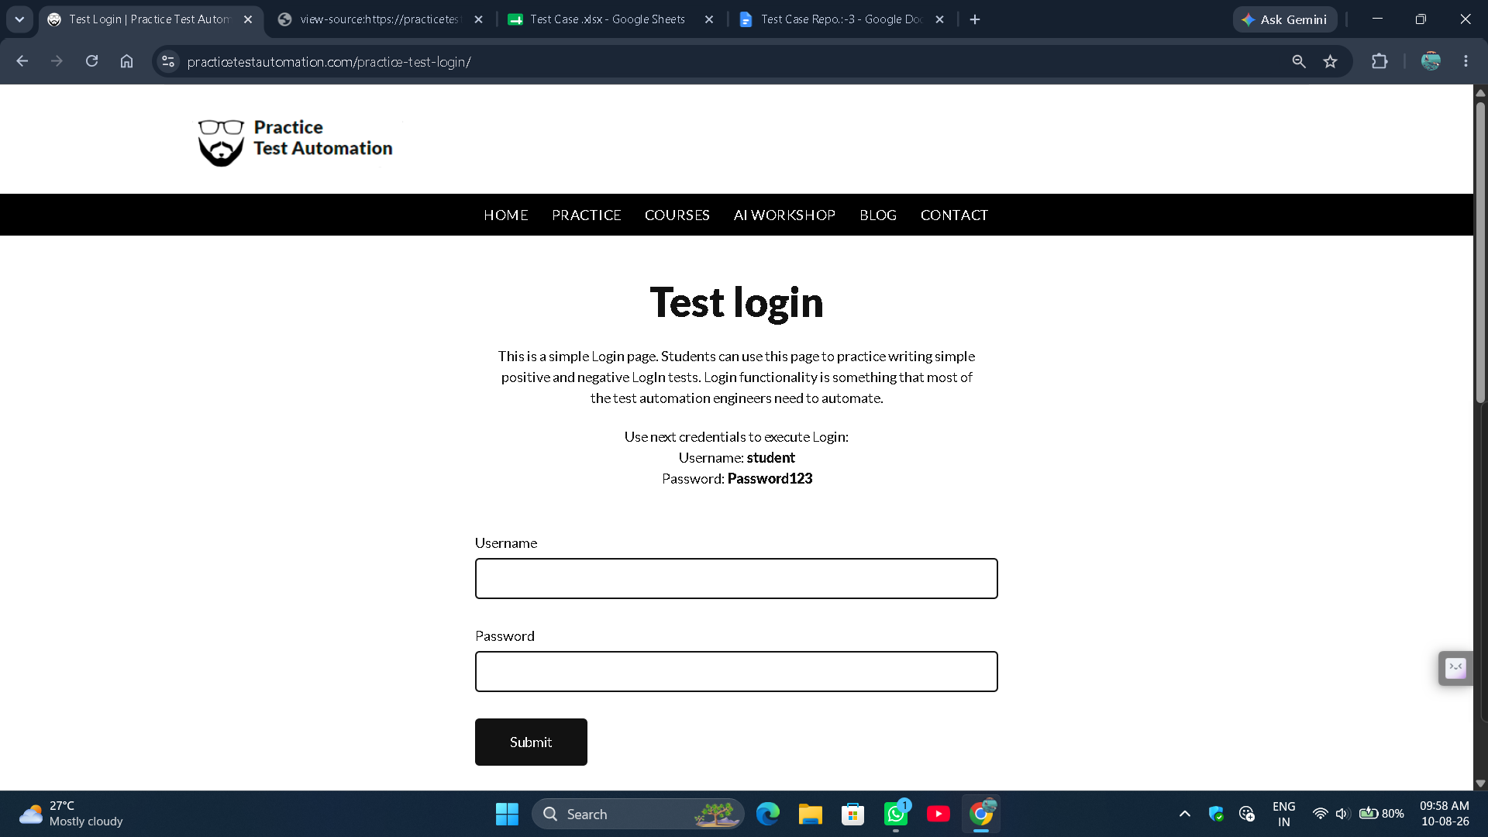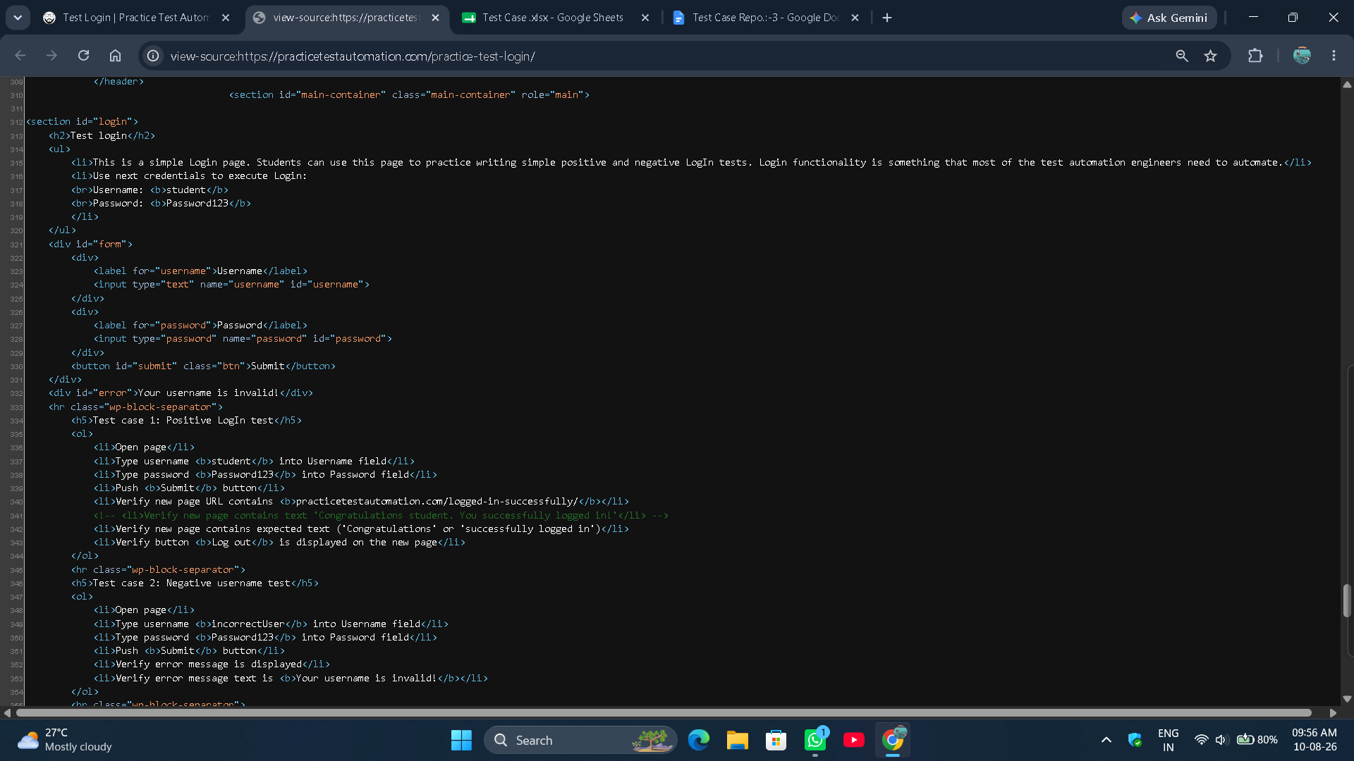

● Scenario ID: 3d

Scenario: Verify Password Field

Test Steps:

Open Login Page.
- Right click on the blank area.
- Click on the view page source.
Screenshots:
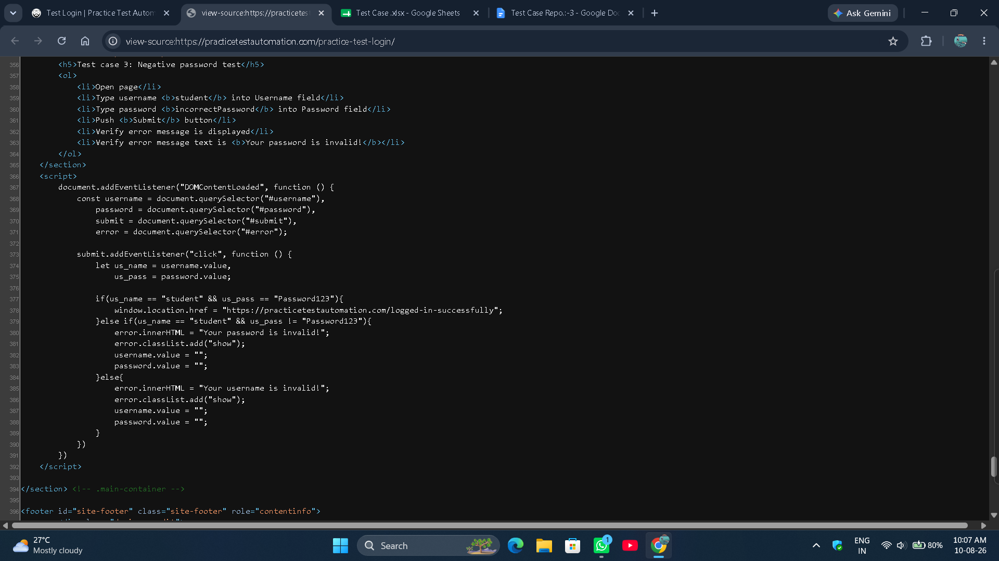

● Scenario ID: 3e
Scenario: Verify Login Button
Test Steps:
- Open Login Page.
- Right click on the blank area.
- Click on the view page source.
Screenshots: